What is VPC peering?

A VPC peering connection is a networking connection between two VPCs that enables you to route traffic between them using private IPv4 addresses or IPv6 addresses. Instances in either VPC can communicate with each other as if they are within the same network.

What are the benefits of using VPC peering?
- Improve security.VPC peering comes with the major benefit of improving security by enabling private connectivity between two or more VPC networks, isolating traffic from the public Internet. Because your traffic never leaves the cloud provider’s network, you reduce a whole class of risks for your stack.
- Save money on network costs.With VPC peering, you save on network transit costs and benefit from improved network latency. Because peering traffic does not leave your cloud provider’s network, that reduces public IP latency. And since peered networks use internal IPs to communicate, transferring data over the cloud provider’s network is cheaper than over the public Internet.
- Get more flexibility for services that don’t need to connect to the Internet.Another reason to use VPC peering is when your instances do not require a public IP address or a network address translation (NAT) configuration to the public Internet. This can be desirable for backend services, where a user wants to block all egress traffic to the public Internet from their instances.

Create an AWS VPC Peering Connection
An AWS (Amazon Web Services) VPC (Virtual Private Cloud) peering connection is a networking connection between two VPCs that enables us to route traffic between them using private IPv4/IPv6 addresses. Instances in either VPC can communicate with each other as if they are within the same network. We can create a VPC peering connection between our own VPCs, or with a VPC in another AWS account. The VPCs can be in different regions (inter-region VPC peering connection).
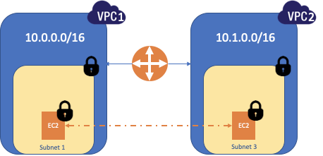

Create VPC Peering Connection (Initiate from the Requester — VPC 1)
To initiate the VPC Peering from VPC 1 (for ex. London), we’ll follow these steps.
Step 1: Login to AWS Console.
Step 2: Search VPC from Services or we can find VPC in “Networking & Content Delivery” section.
Step 3: Go to VPC -> Peering Connection.
Step 4: Select “Create Peering Connection”.
Step 5: Provide a name tag to the Peering Connection.
Step 6: Select a local VPC (Requester) to peer with. (Local VPC to initiate the request), it’ll show us the CIDR Block associated with the local VPC.
Step 7: Select another VPC to peer with. Here, we can select a VPC from the same account or another account. We can also select from the same region and from another region (inter-region VPC Peering Connection) as well.
Step 8: Provide target VPC (Accepter) ID and click on Create Peering Connection.
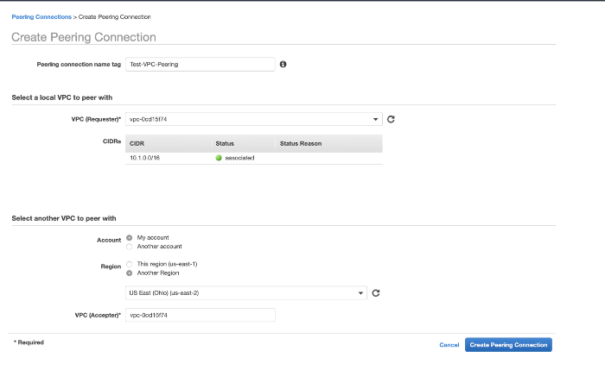
Now, we can see the Peering Connection is initiated and status is “Pending Acceptance”, we need to accept the request on destination VPC (VPC 2).

Accept VPC Peering Connection (accept from the Accepter — VPC 2)
We can see the same status on Accepter VPC (VPC 2) as well.
Step 1: Select the pending VPC Peering Connection
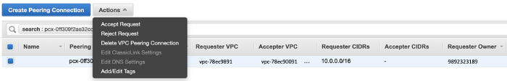
Step 2: Select “Accept Request” and Accept Request confirmation comes.
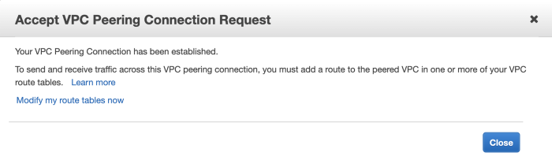

VPC Peering Connection is active
We can check that the status is now active on both VPCs.

Some additional steps to complete the connection
We’ve completed the Peering Connection procedure but still, we need to follow some additional step to complete the connectivity between 2 VPCs.
Step 1: Create Routes on both ends.
On VPC 1, we need to provide CIDR for destination VPC (VPC 2) and target should be “Peering Connection”. Click on “Save routes”.
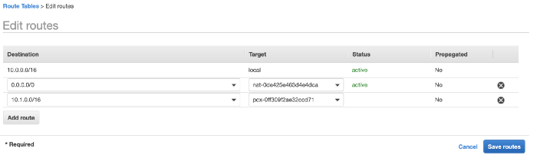
On VPC 2, we need to provide CIDR for destination VPC (VPC 1) and target should be “Peering Connection”. Click on “Save routes”.
Step 2: Allow respective CIDR on the “Security Group” of particular service so that we can establish the connection to that service. I allowed CIDR on destination EC2 virtual machine’s Security Group.
Step3: Ping destination service (EC2) from source to check if everything is configured properly.

Create an AWS VPC Peering Connection
An AWS (Amazon Web Services) VPC (Virtual Private Cloud) peering connection is a networking connection between two VPCs that enables us to route traffic between them using private IPv4/IPv6 addresses. Instances in either VPC can communicate with each other as if they are within the same network. We can create a VPC peering connection between our own VPCs, or with a VPC in another AWS account. The VPCs can be in different regions (inter-region VPC peering connection).

Create VPC Peering Connection (Initiate from the Requester — VPC 1)
To initiate the VPC Peering from VPC 1 (for ex. London), we’ll follow these steps.
Step 1: Login to AWS Console.
Step 2: Search VPC from Services or we can find VPC in “Networking & Content Delivery” section.
Step 3: Go to VPC -> Peering Connection.
Step 4: Select “Create Peering Connection”.
Step 5: Provide a name tag to the Peering Connection.
Step 6: Select a local VPC (Requester) to peer with. (Local VPC to initiate the request), it’ll show us the CIDR Block associated with the local VPC.
Step 7: Select another VPC to peer with. Here, we can select a VPC from the same account or another account. We can also select from the same region and from another region (inter-region VPC Peering Connection) as well.
Step 8: Provide target VPC (Accepter) ID and click on Create Peering Connection.
Now, we can see the Peering Connection is initiated and status is “Pending Acceptance”, we need to accept the request on destination VPC (VPC 2).

Accept VPC Peering Connection (accept from the Accepter — VPC 2)
We can see the same status on Accepter VPC (VPC 2) as well.
Step 1: Select the pending VPC Peering Connection
Step 2: Select “Accept Request” and Accept Request confirmation comes.

VPC Peering Connection is active
We can check that the status is now active on both VPCs.

Some additional steps to complete the connection
We’ve completed the Peering Connection procedure but still, we need to follow some additional step to complete the connectivity between 2 VPCs.
Step 1: Create Routes on both ends.
On VPC 1, we need to provide CIDR for destination VPC (VPC 2) and target should be “Peering Connection”. Click on “Save routes”.
On VPC 2, we need to provide CIDR for destination VPC (VPC 1) and target should be “Peering Connection”. Click on “Save routes”.
Step 2: Allow respective CIDR on the “Security Group” of particular service so that we can establish the connection to that service. I allowed CIDR on destination EC2 virtual machine’s Security Group.
Step3: Ping destination service (EC2) from source to check if everything is configured properly.

VPC Peering or Transit Gateway?
There are two different approaches to connect multiple VPCs. One option is to use VPC Peering. Creating a peering connection is simple: the owner of VPC A creates a peering request, and the owner of VPC B accepts the peering request. After the virtual peering is in place, all you need to do is to update the routing tables.
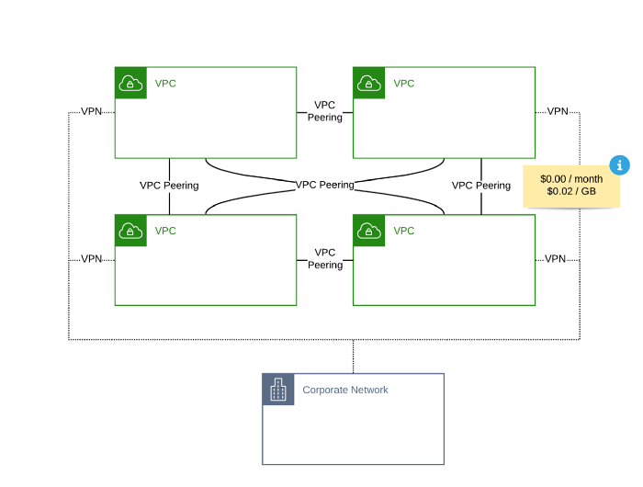
However, you need to set up a VPC Peering between every VPC. Therefore, the number of VPC Peering grows exponentially with the number of VPCs that you need to connect.
Since 2018, there is a second option to enable communication between networks: AWS Transit Gateway. First and foremost, Transit Gateway acts as a gateway connecting up to 5.000 networks. After attaching a VPC to a Transit Gateway, you need to update the routing tables of your subnets as well. Additionally, defining custom route tables to configure the routing within the Transit Gateway is possible as well.
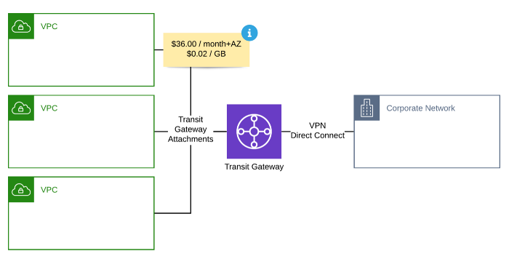
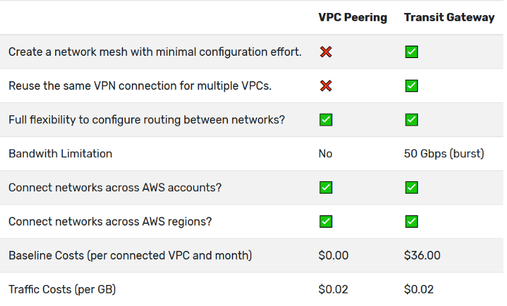

Thank you

